AI-Accelerated .NET Modernization — Business Plan
Oct 1, 2026

Executive summary
The business sells one outcome: legacy Microsoft-stack apps become modern, documented, AI-ready systems that the client's own team can maintain with AI. Year 1 target revenue is about $350K as a solo consultant, with a conservative floor near $150K.
Positioning line: "I modernize legacy .NET apps with AI in half the time of a traditional rewrite, then teach your team to keep them modern."
Three core offers sit inside one client journey:
- Codebase archaeology recovers what the app does before anyone touches it.
- AI-accelerated modernization moves it to current .NET, module by module, behind a test safety net.
- Agent-ready integration exposes the modernized app to AI agents through clean APIs and MCP servers.
A paid assessment is the front door. Team training and monthly retainers turn one-off projects into recurring revenue. A YouTube series that modernizes a real legacy app on camera is the main credibility and lead engine.
All prices below are US-market estimates for a senior independent consultant (effective rate $150–200/hour). Validate them with your first 3–5 sales conversations and adjust.

Target market and ideal client
The ideal client is a mid-sized company (50–2,000 employees) running a business-critical in-house app on .NET Framework, with a small dev team and no appetite for a risky full rewrite.
Trait | What it looks like
Tech stack | .NET Framework 4.x, WebForms, MVC 5, WCF, VB.NET, WinForms, EF6, SQL Server 2012–2016
Pain trigger | Original developers left or retiring; security audit flags; Windows Server / SQL end-of-support; cloud move blocked
Team | 2–15 in-house developers, or one IT manager plus contractors
Budget | $50K–$300K a year on maintenance already; modernization quotes of $250K+ from larger firms
Buyer | CTO, VP/Director of IT, Head of Engineering; CFO signs off
Verticals to lead with (in this order):
- Manufacturing — custom MES, quality, scheduling and ERP-integration apps; pays well and values reliability.
- Nonprofit / fundraising — custom donor, CRM and Blackbaud-integration tools; budgets are smaller but referrals travel fast.
- Automotive suppliers and dealer groups — warranty, parts and supplier-portal apps.
- Telecom (regional carriers, MSPs) — billing, provisioning and support tools.
Pick one as the primary vertical for the first 6 months. The YouTube series stays vertical-neutral so it sells into all four.

Service ladder
Every offer leads to the next, so one client can grow from a $10K assessment to $150K+ over 12–18 months.
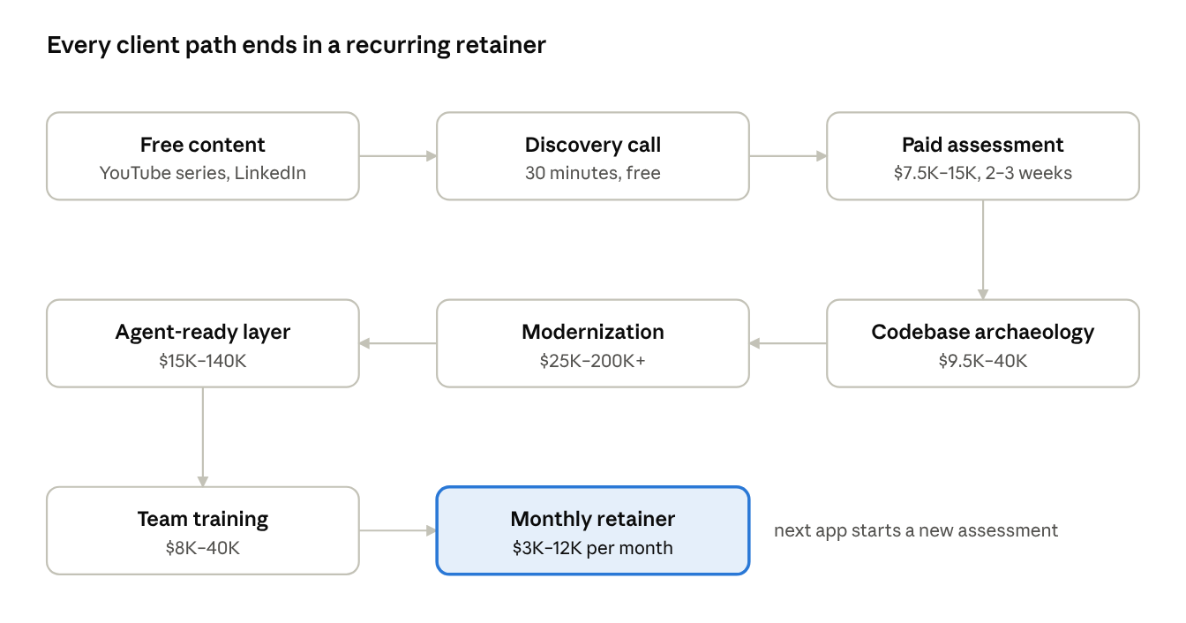
service ladder · 8 steps, prices from this plan
Clients can skip steps (a well-documented app goes straight to modernization), but every engagement is proposed toward a retainer, and retainer clients are the natural buyers of the next app's assessment.

Offer 1: AI-accelerated legacy .NET modernization
Fixed-price migration of a legacy .NET app to current .NET, priced by size and complexity, always preceded by a paid assessment. AI agents do the bulk conversion; you own architecture, verification and sign-off.
Typical scope: .NET Framework to modern .NET (LTS), WebForms or MVC 5 to Blazor or ASP.NET Core, WCF to REST or gRPC, EF6 to EF Core, on-prem to Azure, plus CI/CD.
Method: assessment → characterization tests → convert one module (pilot) → convert the rest in sprints → parallel run → cutover.
Package | App size (rough) | Duration | Price
Modernization Assessment (front door) | Any | 2–3 weeks | $7,500–$15,000
Pilot module | One module or vertical slice | 4–6 weeks | $25,000–$45,000
Small app migration | Under 50K lines, 1–2 integrations | 6–10 weeks | $40,000–$90,000
Mid-size app migration | 50K–200K lines, several integrations | 3–6 months | $90,000–$200,000
Large app (phased) | 200K+ lines | Per phase | $60,000–$120,000 per phase
Assessment deliverables: dependency and risk map, effort estimate per module, target architecture, fixed-price quote for the migration. Credit 50% of the assessment fee if they sign the migration within 60 days.
Pricing logic: a traditional firm quoting a mid-size rewrite often lands at $250K–$500K. Price at 40–60% of that. AI should cut your hours enough to keep your effective rate above $200/hour; measure this on every project and on the YouTube demo.
Guardrails: fixed price per phase only, written change-control process, client signs off each module's tests before conversion.

Offer 2: Codebase archaeology and knowledge recovery
A fixed-price engagement that turns an undocumented system into documentation, tests and AI context files the team can use immediately. It is the easiest first sale: low risk, no production changes, useful even if they never modernize.
Deliverables:
- Architecture overview and diagrams (system context, components, data flows)
- Business rules catalog: every rule found in code, with file location and plain-English description
- Data dictionary for the main database
- Characterization tests on the 5–10 most critical workflows
- AI context files (for example CLAUDE.md, copilot-instructions.md) so any AI coding tool understands the codebase
- "Bus factor" report: which areas only one person understands, and the risk
Package | Scope | Duration | Price
Snapshot | One app, under 50K lines, docs and AI context files only | 2–3 weeks | $9,500–$14,000
Standard | One app up to 150K lines, full deliverables | 3–5 weeks | $15,000–$30,000
Retiring-expert transfer | Standard plus recorded sessions with the departing developer | 4–6 weeks | $25,000–$40,000
Best buyers: companies where a key developer is leaving, after a merger, or before an audit. Credit the Snapshot fee toward a modernization contract signed within 60 days.

Offer 3: Agent-ready legacy apps
A secure API and MCP (Model Context Protocol) layer that lets AI assistants such as Microsoft Copilot, Claude or in-house agents read from and act on the client's app, without a rewrite. It turns "we have old software" into "our software works with AI."
Typical use cases: a plant supervisor asks an assistant for today's open quality holds; a fundraiser asks for lapsed major donors in a region; a support agent's AI drafts a reply using live order data.
Package | Scope | Duration | Price
Read-only pilot | 3–5 read-only tools over one app, one AI client, internal users | 3–4 weeks | $15,000–$25,000
Production integration | Read and write tools, auth (Entra ID), audit log, rate limits, human approval on writes | 6–10 weeks | $40,000–$75,000
Multi-system agent layer | 2–4 apps behind one governed tool layer | 8–14 weeks | $75,000–$140,000
Non-negotiables in every build: least-privilege access, an audit trail of every agent action, human confirmation on any write, and a written data-handling policy for which AI vendors may see what.
Upsell path: modernization makes this cheaper, and this makes the case for modernization. Offer it as the final phase of every Offer 1 project.

Training and retainer packages
Training is sold on the client's own codebase, never as generic AI training; retainers start the month a project ends. Together they should reach 35–45% of revenue by month 12.

Training
Package | Format | Price
AI-Assisted Maintenance Workshop | 2 days on their codebase, up to 12 developers | $8,000–$12,000
AI Engineering Enablement Program | 6 weeks: kickoff, weekly sessions, pairing, team guardrails and review policy | $25,000–$40,000
Public cohort course (from month 9) | 4-week online cohort, "Modernize Legacy .NET with AI" | $900–$1,500 per seat
Curriculum core: AI context files, agentic coding workflows, reviewing AI-generated code, test-first changes, security and licensing guardrails, measuring productivity honestly.

Retainers (3-month minimum)
Tier | Includes | Price per month
Essentials | 10 hours, monthly architecture call, review of AI-generated pull requests, dependency and security updates | $3,000–$3,500
Growth | 25 hours, bi-weekly calls, priority support, small enhancements, quarterly modernization roadmap | $6,500–$7,500
Fractional modernization lead | About 2 days a week: own the roadmap, mentor the team, vendor and AI-tool decisions | $10,000–$12,000
Unused hours do not roll over. Work beyond the tier is billed at $200/hour or quoted as a fixed-price add-on.

YouTube demo series: "Legacy to Modern with AI"
Season 1 is an 11-episode, end-to-end modernization of a real legacy .NET app, filmed so each episode demonstrates one paid offer. The goal is credibility and booked calls, not ad revenue: 1,000–5,000 subscribers in year 1 is a good result for this niche.
Demo app: Microsoft's archived eShopModernizing repository (MIT license). It includes a WebForms app, an MVC 5 app and a WinForms + WCF N-tier app, all on .NET Framework with SQL Server. Microsoft only containerized it ("lift and shift"), so a true modernization with AI is fresh content. Use the WinForms + WCF app for Season 1; it is the most painful and most common in your target industries.
Season 2 (months 7–12): build your own realistic VB.NET WinForms "donor management" or "plant quality tracker" app (dated patterns, stored procedures, no tests) and modernize it. This speaks directly to your primary vertical.ready whe

Season 1 episodes
# | Episode | Offer it sells | Length
1 | "I modernized a 2017 WinForms + WCF app with AI. Here's the honest result" (trailer with the final before/after) | All | 8–10 min
2 | AI-powered legacy assessment: dependency map, risk report, effort estimate in one afternoon | Assessment | 15–20 min
3 | Codebase archaeology: AI recovers the business rules, diagrams and data dictionary | Offer 2 | 15–20 min
4 | Build the safety net: AI-generated characterization tests before changing a line | Offer 2 / 1 | 15–20 min
5 | Migration part 1: .NET Framework to modern .NET with an AI coding agent | Offer 1 | 20–25 min
6 | Migration part 2: WCF to a REST API, EF6 to EF Core | Offer 1 | 20–25 min
7 | Migration part 3: WinForms to Blazor (and when to keep the desktop app) | Offer 1 | 20–25 min
8 | Deploy to Azure with CI/CD, and what it costs per month | Offer 1 | 15 min
9 | Make it agent-ready: an MCP server so AI assistants can use the catalog safely | Offer 3 | 20 min
10 | How a dev team maintains this with AI: context files, review rules, guardrails | Training / retainer | 15–20 min
11 | Retrospective: hours spent, AI tool cost, what AI got wrong, versus a traditional estimate | All (case study) | 12–15 min
Rules that make the series sell: show the AI's mistakes and how you caught them (this is your value); keep a running time-and-cost log from day one; end every episode with one call to action to the free checklist.

Production plan
- Build first, film second. Do the whole migration privately in months 1–2, then re-record it cleanly. This avoids a stalled series.
- Cadence: one long episode every 2 weeks, plus 3 Shorts and 2 LinkedIn clips cut from each.
- Effort: 8–12 hours per episode for you; outsource editing at $150–400 per episode.
- Gear: good USB microphone, 1080p+ webcam, screen-recording software, simple lighting: $500–1,500 total.
- Repository: publish the modernized code on GitHub, with a branch per episode.

Funnel
Video → free "Legacy .NET Modernization Readiness Checklist" (email capture) → weekly newsletter → 30-minute free call → paid assessment. Track subscribers, checklist downloads, calls booked and assessments sold every month.

Sales and marketing beyond YouTube
Your first 3–5 clients will almost certainly come from your existing network, not YouTube. Spend about 60% of marketing time on direct outreach until month 6.
- Warm network (weeks 1–8): list 100 former colleagues, managers and clients across fundraising, manufacturing, telecom and automotive. Send a personal note offering a free 30-minute "legacy app health check" call. Expect 10–15 conversations and 2–3 paid assessments.
- Founding-client offer: the first 2 assessments at $5,000 in exchange for a case study and testimonial.
- LinkedIn: 3 posts a week: one lesson from the build, one client-style story, one short video clip. Rename your headline to the positioning line.
- Referral partners: managed IT service providers, Microsoft Dynamics and Azure partners, Blackbaud consultants and ERP resellers. They meet legacy apps daily and rarely modernize custom code. Offer 10% of the first project.
- Speaking: local .NET user groups, .NET Conf community events, nonprofit tech events (such as NTEN) and regional manufacturing associations. One talk a quarter.
- Written case studies: every project becomes a one-page case study with hours, cost and outcome.
- Website: a one-page site with the three offers, prices "starting at", the YouTube series and a booking link.
Sales process: discovery call → short written proposal within 48 hours → paid assessment → fixed-price migration quote → training add-on → retainer proposal in the final project week.

Financial projections, year 1
The target scenario reaches about $355K revenue with roughly 1,650 billable hours, an effective rate near $215/hour. Most project revenue lands in months 4–12; months 1–3 are mostly setup, content and the first assessments.
Revenue line | Conservative | Target | Stretch (needs a subcontractor)
Assessments | 3 × $8K = $24K | 5 × $10K = $50K | 8 × $11K = $88K
Codebase archaeology | 1 × $15K = $15K | 2 × $20K = $40K | 3 × $22K = $66K
Modernization projects | 1 × $50K = $50K | 2 × $60K = $120K | 3 × $70K = $210K
Agent-ready integrations | — | 1 × $25K = $25K | 2 × $35K = $70K
Training (incl. cohort) | 2 × $9K = $18K | 3 × $10K = $30K | 4 × $12K + 20 seats = $72K
Retainers (avg. 6 months each) | 2 × $3.5K/mo = $42K | 3 × $5K/mo = $90K | 4 × $6K/mo = $144K
Total revenue | $149K | $355K | $650K
Year 1 operating costs: about $20K–37K.
Cost | Annual estimate
AI coding tools and Azure credits | $4,000–8,000
E&O and cyber liability insurance | $3,000–6,000
Legal (MSA, SOW, NDA templates) and accounting | $4,000–6,000
Video gear and outsourced editing | $4,000–8,000
Website, CRM, email, scheduling | $1,500–3,000
Events, user groups, travel | $3,000–6,000
Cash runway: keep 6 months of personal expenses in reserve before you start; the first sizable project payment may not arrive until month 3 or 4. Bill fixed-price work 40% upfront, 40% at the midpoint and 20% on acceptance.

12-month execution roadmap
Four phases, each closed by a gate; if a gate slips by more than a month, shift time from content to direct outreach until it is met.
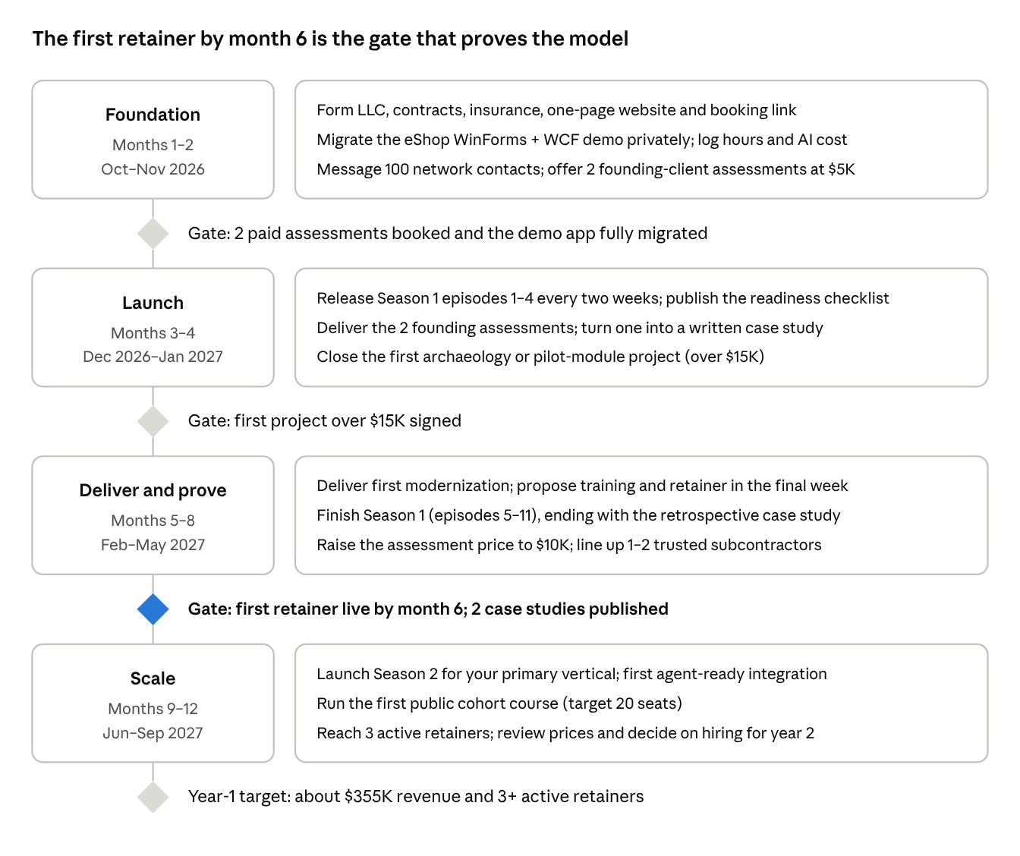
12-month roadmap · 4 phases, 4 gates, starting October 2026
Weekly rhythm once launched: 3 days client delivery, 1 day content (filming, editing, LinkedIn), 1 day sales and outreach.

Risks, mitigations and business setup
The two risks that sink most solo consultancies are a fixed-price project that overruns and an empty pipeline after the first big project; the plan is built around both.
Risk | Mitigation
Fixed-price overrun | Paid assessment first; price per phase; written change control; 15% contingency in every quote
Client code sent to AI tools | Enterprise AI plans that do not train on customer data, or tools on the client's own accounts; data-handling clause in the MSA
AI-generated bugs or license issues | Characterization tests before conversion, human review of every change, dependency license scan
Pipeline gaps (feast or famine) | Retainers by month 6; keep 1 day a week for marketing even when busy
YouTube grows slowly | Treat it as a sales asset you send to prospects, not as the lead source; outreach carries months 1–6
AI tools change quickly | Sell a method (assess, test, convert, verify, train), not a specific tool
Solo capacity ceiling | Line up 1–2 trusted .NET subcontractors by month 6
Business setup checklist (month 1):
- ☐ Form an LLC; ask an accountant about S-corp election once profit exceeds roughly $80K–100K
- ☐ Business bank account and bookkeeping software
- ☐ Lawyer-reviewed Master Services Agreement, SOW template and mutual NDA (IP ownership, AI-tool use and liability cap clauses)
- ☐ E&O (professional liability) and cyber insurance
- ☐ Business name, domain, one-page website, booking link
- ☐ Microsoft Partner Network membership (free tier) for credibility and Azure benefits
This plan is not legal or tax advice; confirm the entity, contracts and insurance with a lawyer and accountant in your state.

